ACE-CL-311

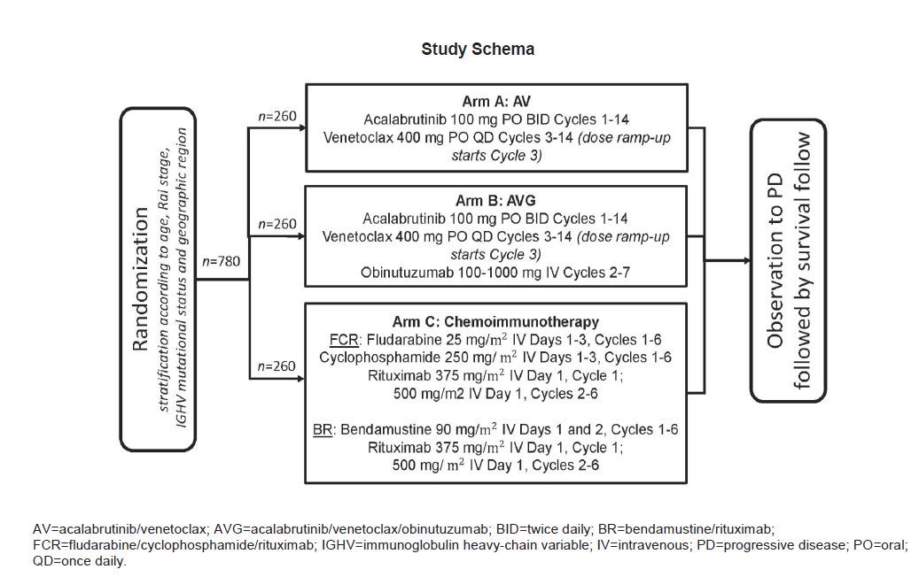

Inclusion criteria
− Men and women ≥18 years of age.
− Eastern Cooperative Oncology Group (ECOG) performance status of 0–2.
o Diagnosis of CLL that meets published diagnostic criteria (see protocol):
o Monoclonal B cells (either kappa or lambda light chain restricted) that are clonally co-expressing B-cell marker (CD19, CD20, and CD23) and CD5.
o Prolymphocytes may comprise <55% of blood lymphocytes.
o Presence of ≥5x109 B lymphocytes/L (5000/μL) in the peripheral blood (at any point since the initial diagnosis).
− Active disease per IWCLL 2018 criteria that requires treatment (see protocol).
− Meet the following laboratory parameters:
o Adequate bone marrow function independent of growth factor or transfusion support within 1 week of Screening, as follows:
o ANC ≥750 cells/μL (0.75x109/L); ANC ≥500 cells/μL (0.50x109/L) in subjects with documented bone marrow involvement of CLL
o Platelet count ≥50,000 cells/μL (50x109/L); platelet count ≥30,000 cells/μL (30x109/L) in subjects with documented bone marrow involvement of CLL
o Serum AST and ALT ≤2.5 x upper limit of normal (ULN).
o Total bilirubin ≤2 x ULN, unless directly attributable to Gilbert’s syndrome
o Estimated creatinine clearance of ≥50 mL/min, calculated using the formula of Cockcroft and Gault (if male, [140-Age] x Mass (kg) / [72 x creatinine mg/dL]; multiply by 0.85 if female); estimated creatinine clearance of ≥70 mL/min for subjects selected by investigator to receive FCR in Arm C.
− Women who are sexually active and can bear children must agree to use highly effective forms of contraception while on the study and for 2 days after the last dose of acalabrutinib, 30 days after the last dose of venetoclax, 6 months after the last dose of fludarabine or bendamustine, 12 months after the last dose of rituximab or cyclophosphamide, or 18 months after the last dose of obinutuzumab, whichever is longer. Highly effective forms of contraception are defined in the protocol.
− Men who are sexually active must agree to use highly effective forms of contraception with the addition of a barrier method (condom) during the study and for 90 days after the last dose of venetoclax, obinutuzumab, or rituximab or 6 months after the last dose of fludarabine, cyclophosphamide, or bendamustine, whichever is longer. Highly effective forms of contraception are defined in the protocol.
− Men must agree to refrain from sperm donation during the study and for 90 days after the last dose of venetoclax, obinutuzumab, or rituximab or 6 months after the last dose of fludarabine, cyclophosphamide, or bendamustine, whichever is longer.
− Willing and able to participate in all required evaluations and procedures in this study protocol, including swallowing capsules and tablets without difficulty.
− Ability to understand the purpose and risks of the study and provide signed and dated informed consent and authorization to use protected health information (in accordance with national and local patient privacy regulations).

Exclusion criteria
− Any prior CLL-specific therapies (except corticosteroid treatment administered due to necessary immediate intervention; within the last 10 days before start of study treatment, only dose equivalents up to 20 mg prednisone daily are permitted).
− Detected del(17p) or TP53 mutation.
− Transformation of CLL to aggressive non-Hodgkin lymphoma (NHL; e.g., Richter’s transformation, prolymphocytic leukemia [PLL], or diffuse large B cell lymphoma [DLBCL]), or CNS involvement by leukemia.
− Any comorbidity or organ system impairment rated with a single Cumulative Illness Rating Scale (CIRS) score of 4 (excluding the eyes/ears/nose/throat/larynx organ system) or a total CIRS score of >6.
− Uncontrolled autoimmune hemolytic anemia or idiopathic thrombocytopenic purpura.
− History of confirmed progressive multifocal leukoencephalopathy (PML).
− Received any investigational drug within 30 days before first dose of study drug.
− Major surgical procedure within 30 days before the first dose of study drug. Note: If a subject had major surgery, they must have recovered adequately from any toxicity and/or complications from the intervention before the first dose of study drug.
− History of prior malignancy that could affect compliance with the protocol or interpretation of results, except for the following:
o Curatively treated basal cell carcinoma or squamous cell carcinoma of the skin or carcinoma in situ of the cervix or carcinoma in situ of the prostate at any time prior to study
o Other cancers not specified above that have been curatively treated by surgery and/or radiation therapy from which subject is disease-free for ≥3 years without further treatment
− Significant cardiovascular disease such as symptomatic arrhythmias, congestive heart failure, or myocardial infarction within 6 months of Screening, or any Class 3 or 4 cardiac disease as defined by the New York Heart Association Functional Classification at Screening. Note: Subjects with controlled, asymptomatic atrial fibrillation are allowed to enroll on study.
− Malabsorption syndrome, disease significantly affecting gastrointestinal function, or resection of the stomach, or extensive small bowel resection that is likely to affect absorption, symptomatic inflammatory bowel disease, or partial or complete bowel obstruction, or gastric restrictions and bariatric surgery such as gastric bypass.
− Received a live virus vaccination within 28 days of first dose of study drug.
− Known history of infection with HIV.
− Any active significant infection (e.g., bacterial, viral or fungal, including subjects with positive cytomegalovirus [CMV] DNA polymerase chain reaction [PCR]).
− Serologic status reflecting active hepatitis B or C infection.
o Subjects who are hepatitis B core antibody (anti-HBc) positive and who are hepatitis B surface antigen (HBsAg) negative will need to have a negative PCR result before randomization and must be willing to undergo DNA PCR testing during the study. Those who are HbsAg-positive or hepatitis B PCR positive will be excluded.
o Subjects who are hepatitis C antibody positive will need to have a negative PCR result before randomization. Those who are hepatitis C PCR positive will be excluded.
− History of known hypersensitivity or anaphylactic reactions to study drugs or excipients, xanthineoxidase inhibitors, or rasburicase.
− History of stroke or intracranial hemorrhage within 6 months before first dose of study drug.
− History of bleeding diathesis (e.g., hemophilia, von Willebrand disease).
− Requires or receiving anticoagulation with warfarin or equivalent vitamin K antagonists.
− Requires treatment with a strong cytochrome P450 3A (CYP3A) inhibitor. The use of strong or moderate CYP3A inhibitors or inducers within 7 days of the first dose of study drug is prohibited.
− Breastfeeding or pregnant.
− Concurrent participation in another therapeutic clinical trial.
10. Pregnant or lactating females.
11. Major surgical procedure (including open biopsy) within 28 days prior to the first study treatment, or anticipation of the need for major surgery during the course of the study treatment.
12. Uncontrolled hypertension (systolic > 150 mm Hg and/or diastolic > 100 mm Hg) or clinically significant (i.e. active) cardiovascular disease.
13. Evidence of any other medical conditions (such as psychiatric illness, physical examination or laboratory findings) that may interfere with the planned treatment, affect patient compliance or place the patient at high risk from treatment-related complications.
14. Known HIV, Hepatitis B and/or Hepatitis C infections.
15. History of hypersensitivity to the investigational medicinal product or to any excipient present in the pharmaceutical form of the investigational medicinal product.

