HD21

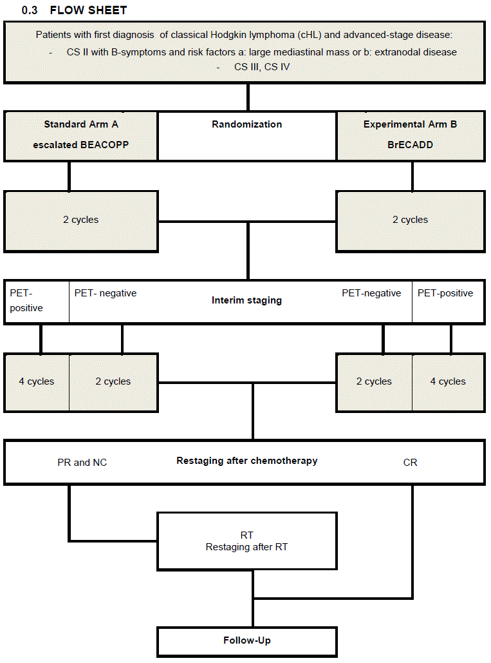

Inclusion criteria
Classical Hodgkin lymphoma
Stage IIB with large mediastinal mass and/or extranodal disease
Stage III-IV
Age 18-60 yrs
Written informed consent
Normal organ function

Exclusion criteria
Chemotherapy or radiotherapy in medical history
Malignant disease within the last 5 yrs
Prior or concurrent disease that prevents treatment according to protocol
Incomplete diagnosis of the disease stage

